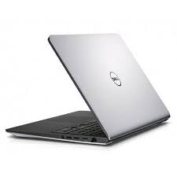

Dell Inspiron 15

* Intel Core I7 4th Gen
* 4 MB 8 GB 2.0 Ghz
* Dell. Inspiron 5547
* AMD / ATI Graphics
* **Rs.59,900**